# INTRODUCTION

* 1. Overview

Using data visualization techniques analyze the performance and efficiency of the Radisson hotels.

* 1. Purpose

Using data visualization techniques in retaining the market share and revenue of hotel Radisson .

1. **Problem Definition & Design Thinking**
   1. 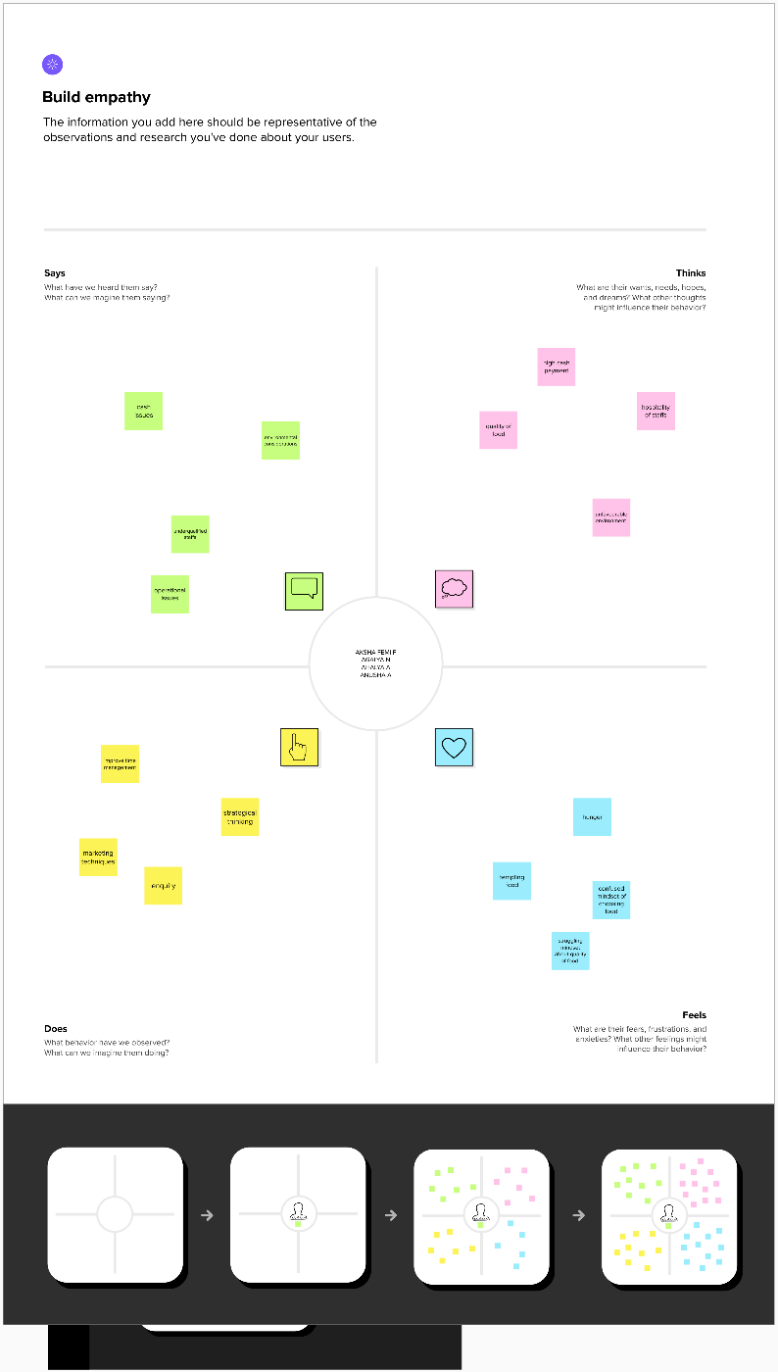Empathy Map
   2. Ideation & Brainstorming Map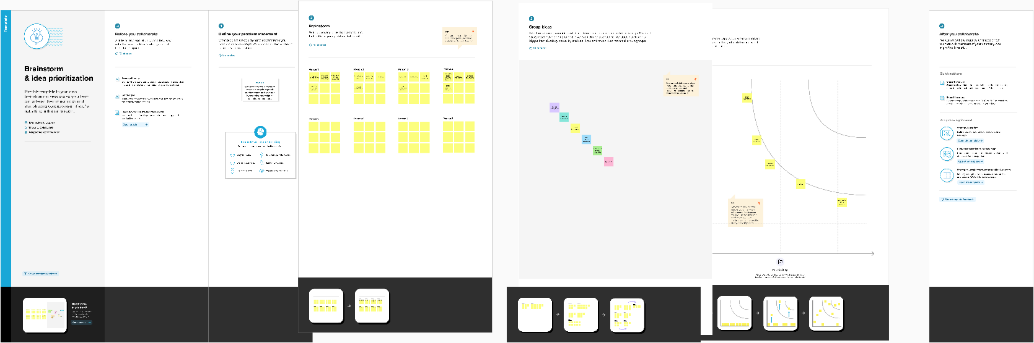

# RESULT

# 

# 

# 

# 

# 

# 

# ADVANTAGES & DISADVANTAGES

Using data visualization techniques in business helps in better understanding , sales analysis ,finding relationships between events , exploring opportunities and trends , modification of data etc.

Some of the disadvantages are they are biased and may give estimation not accurately.

# APPLICATIONS

It can be applied in

* Customer data analysis
* Market segmentation
* Real-time data
* Hotel pricing strategies
* Managing hotel booking channels
* Inventory management
* Demand forecasting.

# CONCLUSION

We can understand the importance of data visualization in the improvement of business and got to know how to work on it.

# FUTURE SCOPE

Strengthening in revenue management by introducing various technologies like artificial intelligence in hotels that may reduce work loads ,cost and attracts more. Data analytics helps in

# APPENDIX

A. Source Code

https://drive.google.com/file/d/1xzGEv_LEtL0h2_v1lAGbLgJ7n4EujIi7/view?usp=share_link